Homework

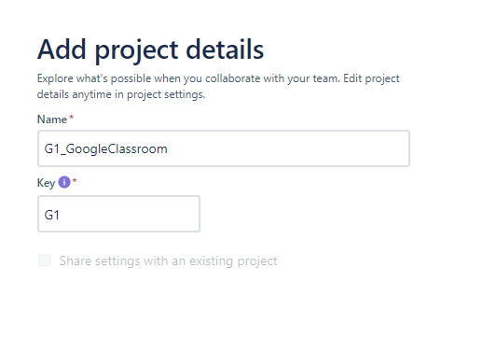1- Create new project **scrum**board name **GoogleClassroom**: **G1-**

2 - Create **2 sprints** (S*print 1 and Sprint 2*)

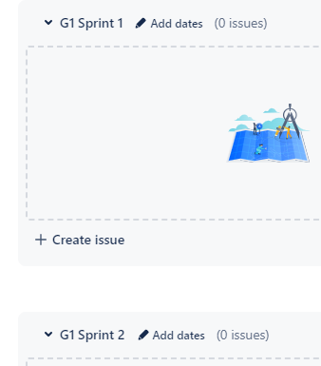

3- Create **user story** and **description**in **backlog**following document

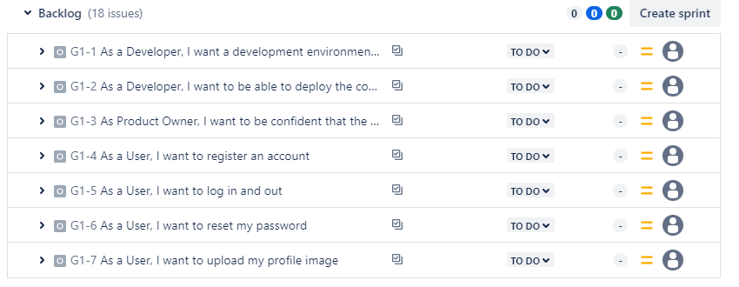

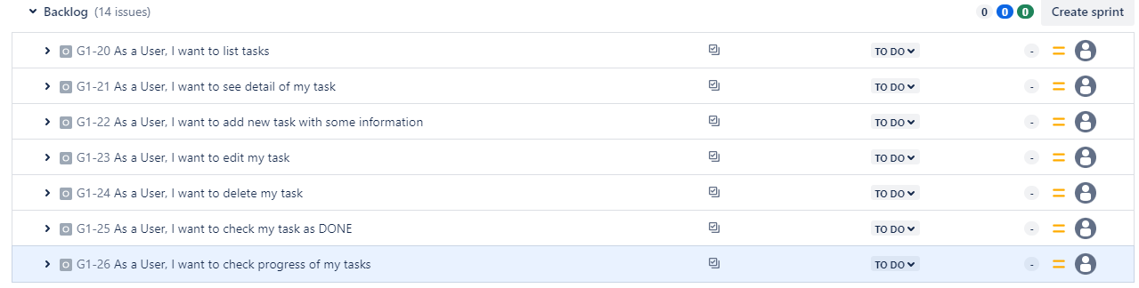

 4 - Create **sub task** and **estimate time**

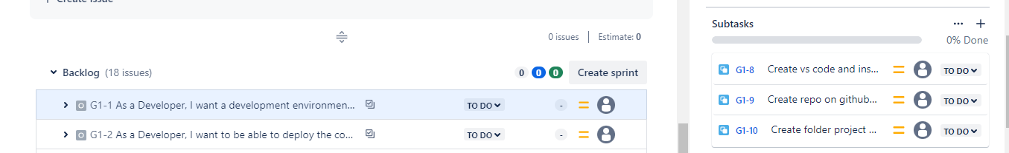

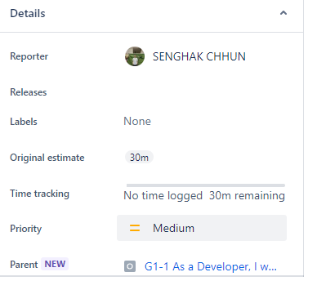

5- Move **sub task**to each sprint follow document

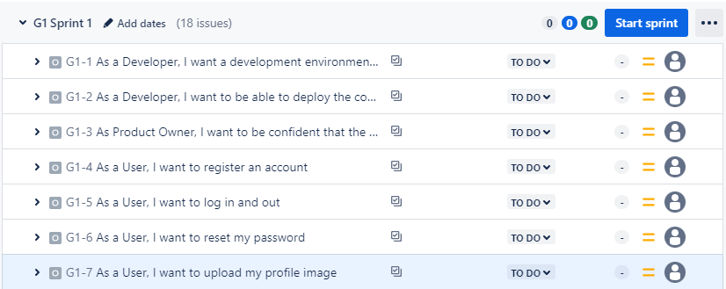

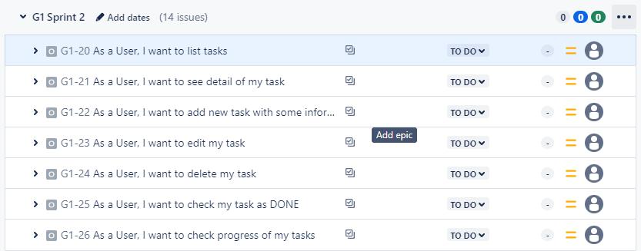

6. Add [*rady.y@passerellesnumeriques.org*](https://mail.google.com/mail/?view=cm&fs=1&to=rady.y%40passerellesnumeriques.org&authuser=0) to your project

